

Addition of “Vendor Part Number” Attribute in Financial Report (FR) & Financial Import
1. Background
The customer has requested a minor enhancement in the Financial Report (FR) and Financial Import process to improve BOQ reconciliation accuracy and efficiency.

2. Proposed Enhancement
Introduce a new static attribute in the Financial Report named:
Vendor Part Number
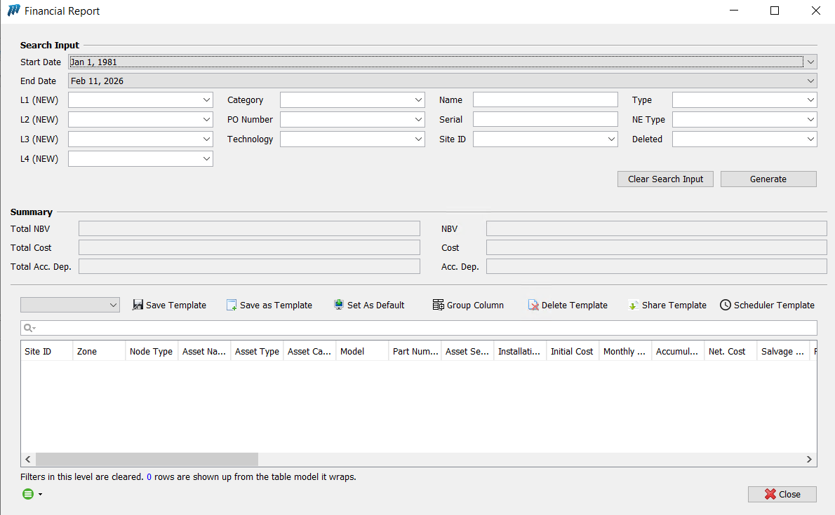

3. Functional Requirements
3.1 Attribute Creation
- A new static field called “Vendor Part Number” shall be added to the Financial Report (FR).
- The same field shall be supported in the Financial Import template/process.
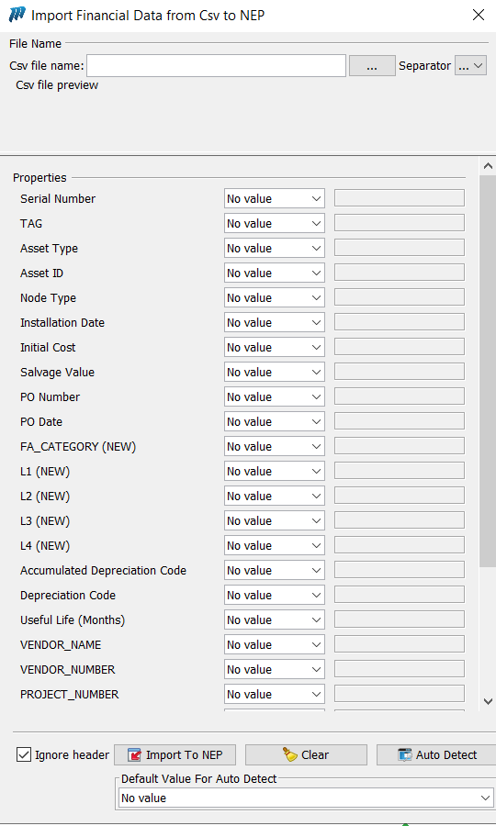

3.2 Data Population Logic
The field shall behave as follows:
- Manual Population via Import
  - If the dumps do not contain this field, it shall be possible to populate the Vendor Part Number manually through the Financial Import.

4. Business Justification
- To facilitate smoother and more accurate BOQ reconciliation.
- To reduce dependency on external references for vendor part number identification.
- To enhance financial reporting accuracy.

5. Impact Analysis (To Be Assessed by Development Team)
- Financial Report (FR) structure update
- Financial Import template modification
- Possible reporting/export impact
- Workflow approval under Financial Modification.

